## manage-currency-conversion-factor-service

### H2 DB Entries

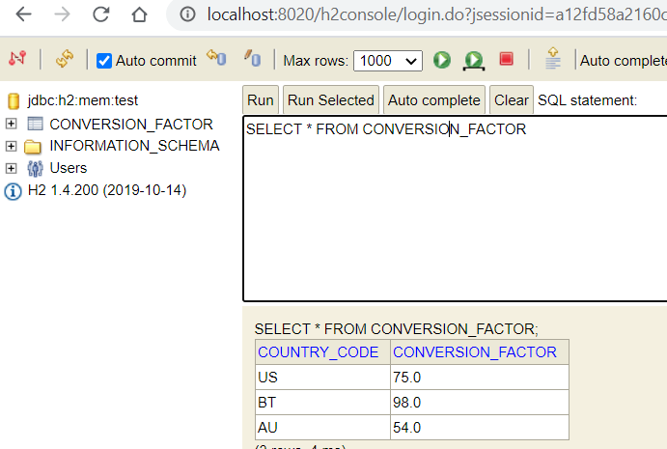

<http://localhost:8020/conversion/getConversionFactor/BT>

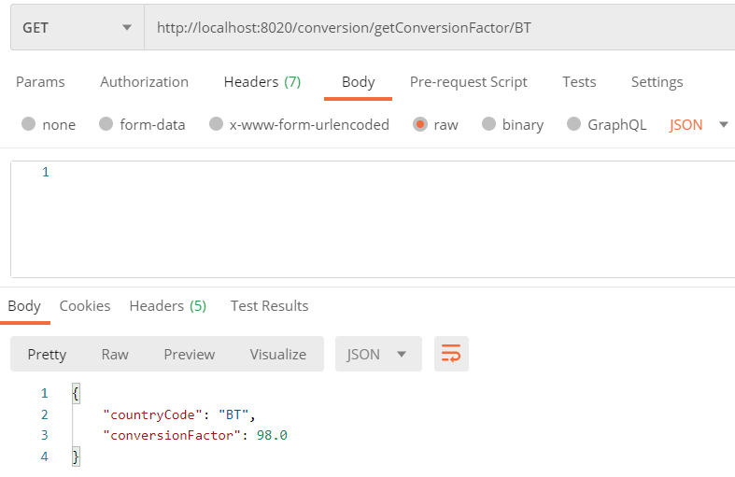

<http://localhost:8020/conversion/addConversionFactor>

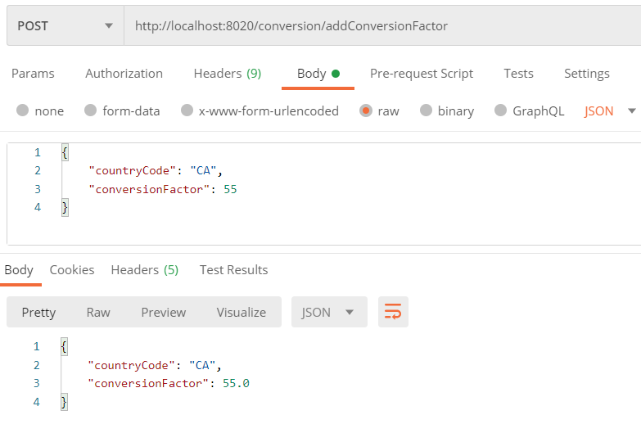

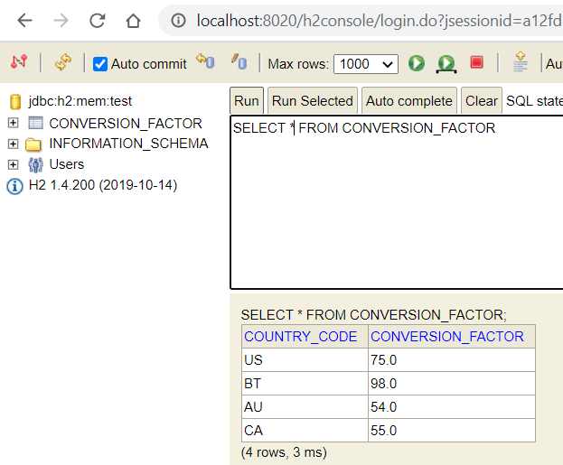

<http://localhost:8020/conversion/updateConversionFactor>

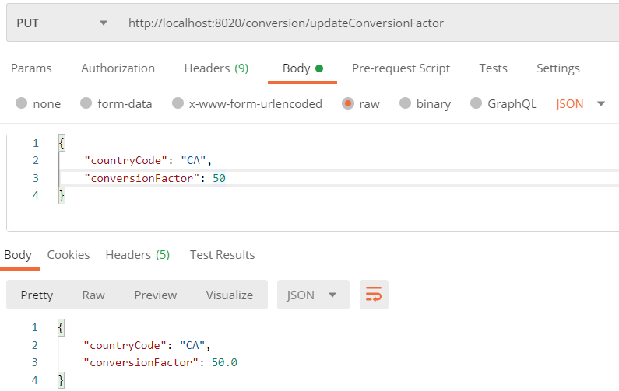

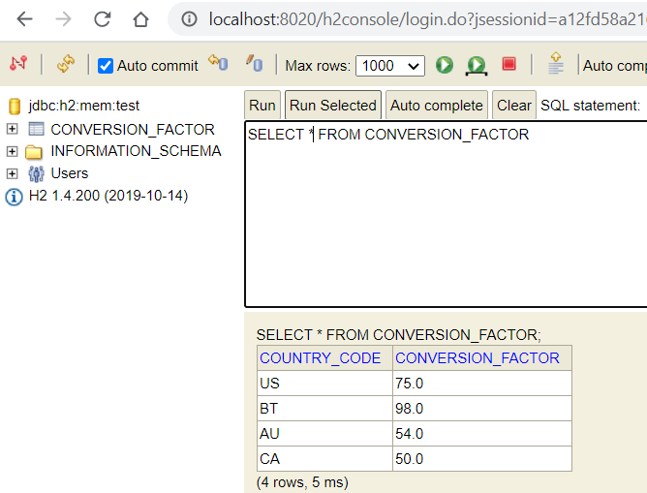

## currency-conversion-service

<http://localhost:8030/currency/convertCurrency>

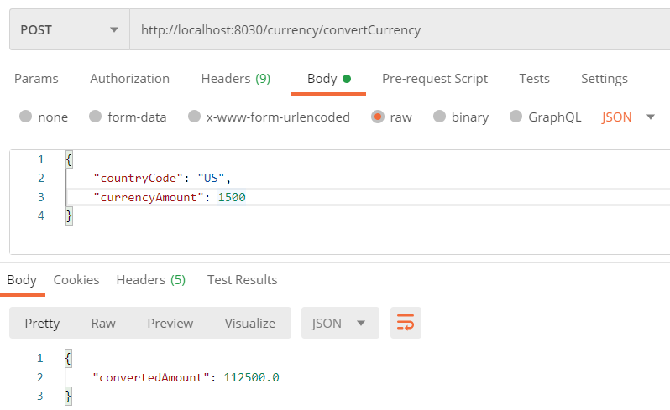

<http://localhost:8030/currency/convertCurrencyFeign>

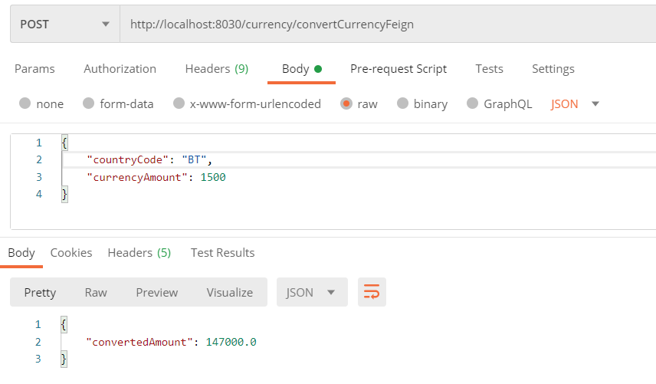

## Zipkins

